SRS DOCUMENT

PROJECT: BAKERY WEBSITE (BLISSFUL BITES)

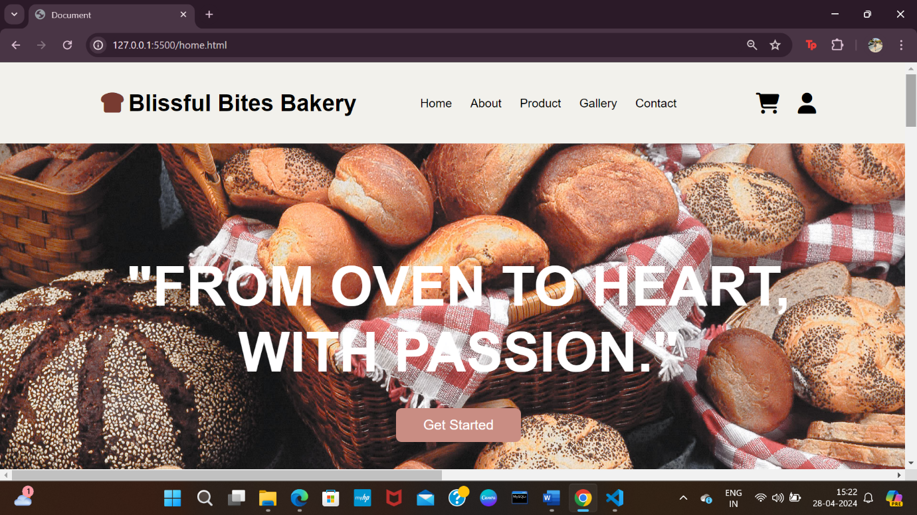

SUBMITTED BY: RIYA

SAP ID: 500101787

ROLL NO: R2142220617

BATCH: 09 (AIML)

PURPOSE:

A bakery can exhibit its goods, services, and brand identity online with the use of a website. It functions as a round-the-clock online marketplace for prospective clients.The bakery is able to showcase its whole product line on the internet, including bread, pastries, cakes, cookies, and specialized goods. Detailed descriptions and attractive photos can draw in customers and motivate them to buy. The bakery may reach a larger audience and attract clients who might not be able to visit the actual store in person by having an online presence. Consumers with hectic schedules or limited mobility will also find additional convenience in the online ordering and delivery choices.

SCOPE:

Customers will be able to view bakery products, place orders, and make payments online through the bakery website. Moreover, facilities for managing product listings, orders, and customer data will be included for administrators.

PRODUCT FEATURES:

User authentication: Users are able to create accounts, log in, and access their information.

Product Catalog: List baked goods together with their names, descriptions, prices, and pictures.

Shopping Cart: Customers can browse the contents of their cart, add or delete things, and check out.

Order Management: Users are able to check information, status, and order history.

Admin Dashboard: Listing products, viewing orders, and managing user accounts are all available to administrators.

Integration of Payment Gateways: Safe processing of orders' payments.

TECHNOLOGY SCOPE:

* Html
* Css
* Javascript (JS)
* Angular JS

SCREENSHOTS OF THE WEBSITE:

The home page of the website, which includes a “Login/Signup” button, all the links to other pages

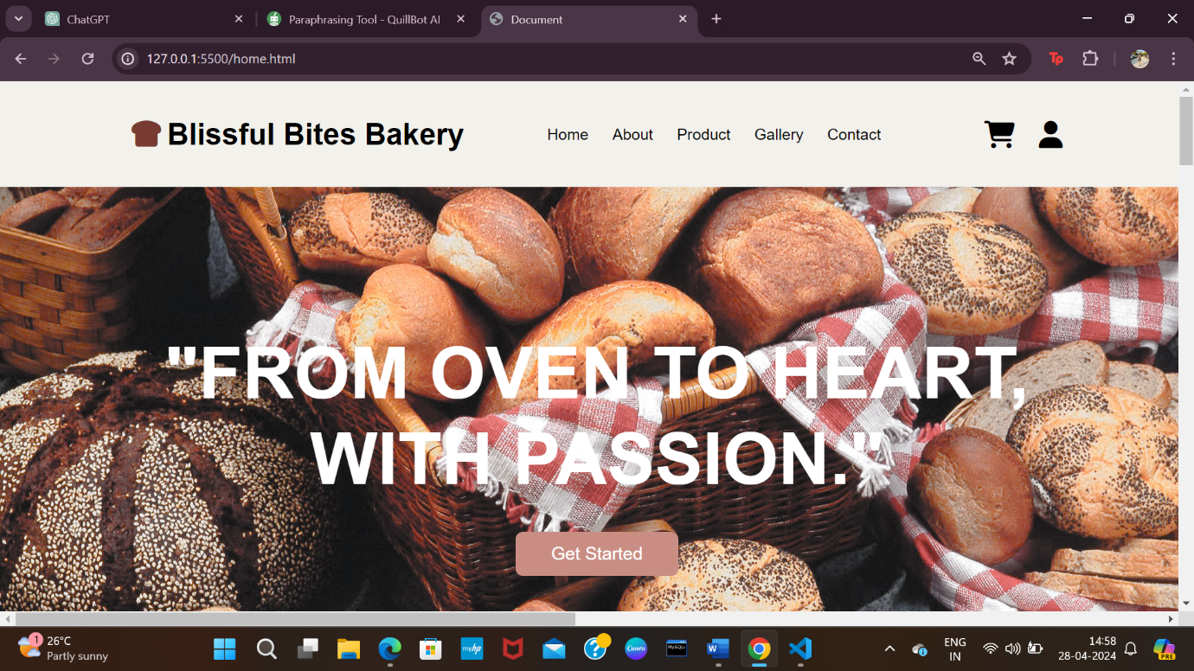

The “Login/Signup” button logs in or signs up the user

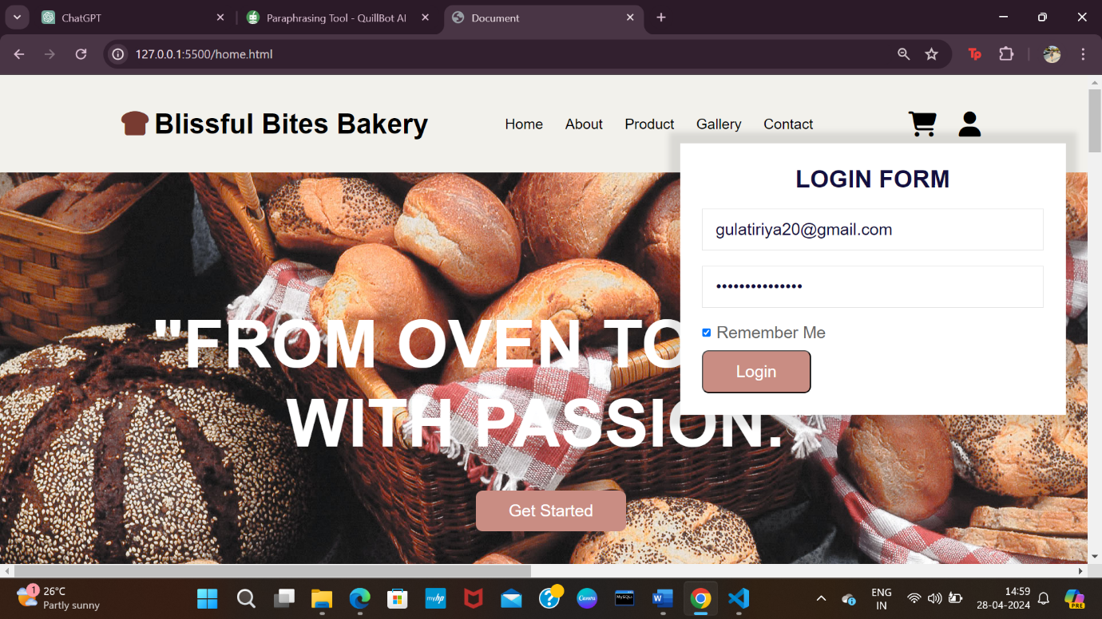

A further view:

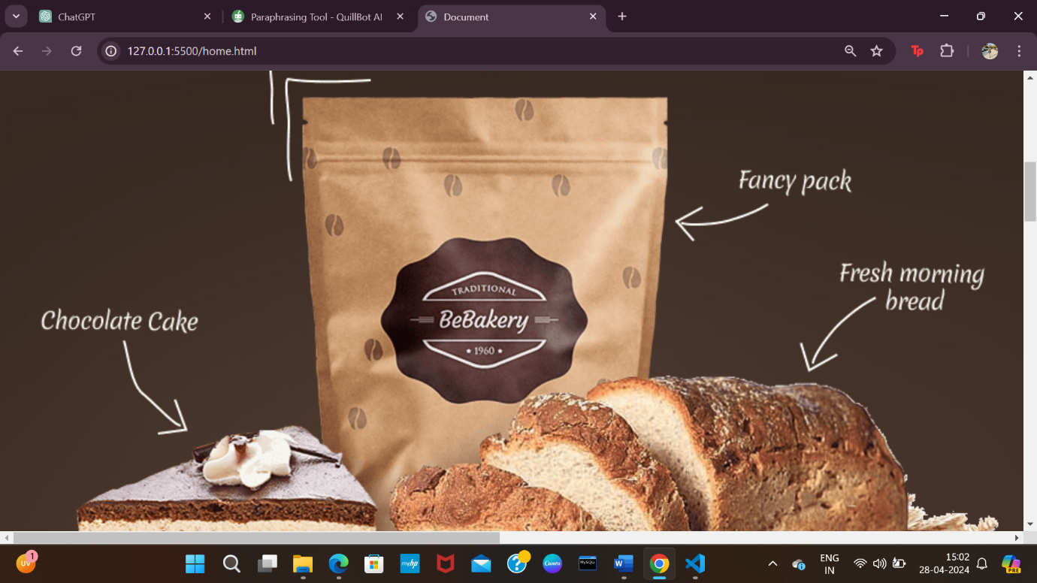

Few of the item’s description

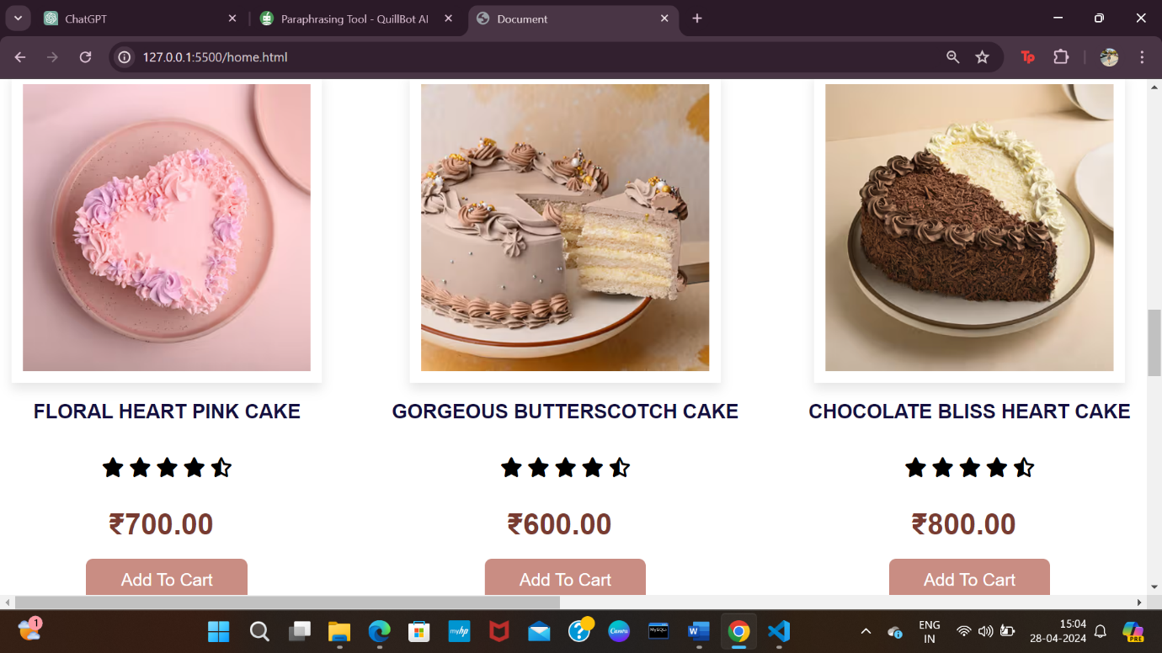

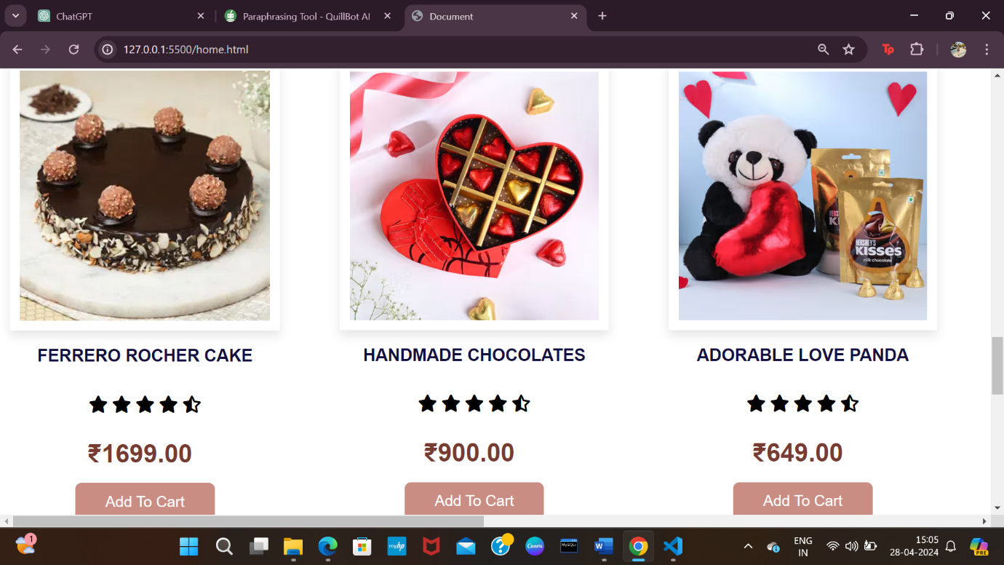

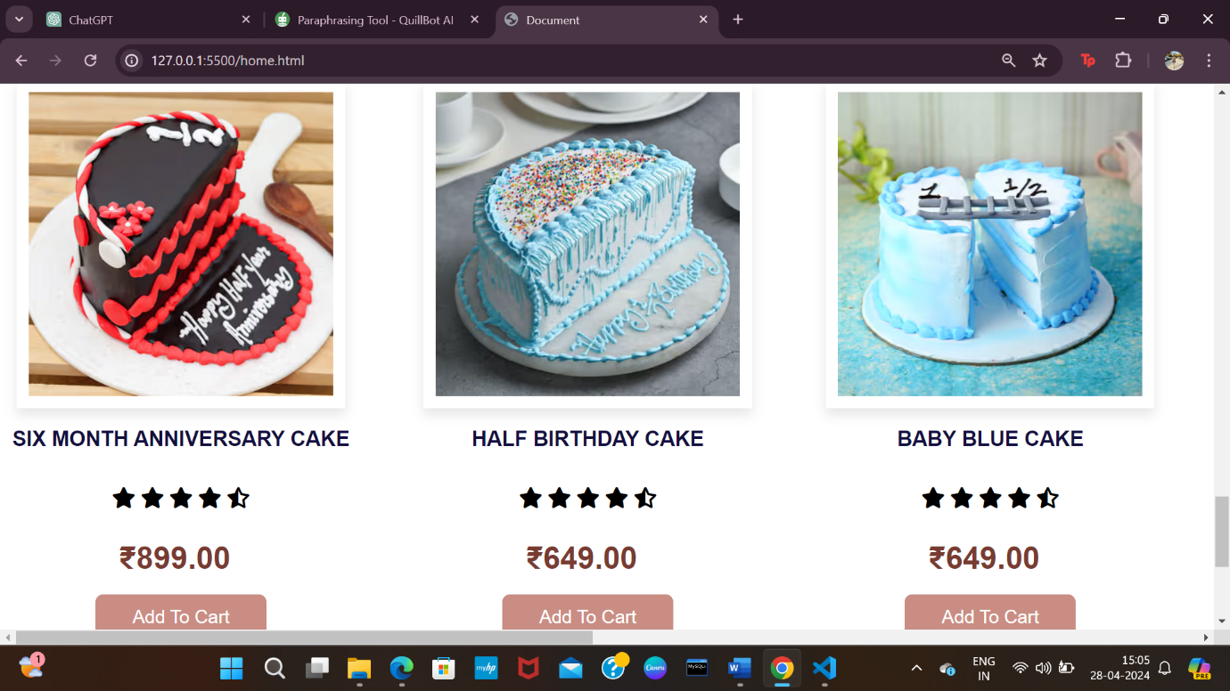

About Page

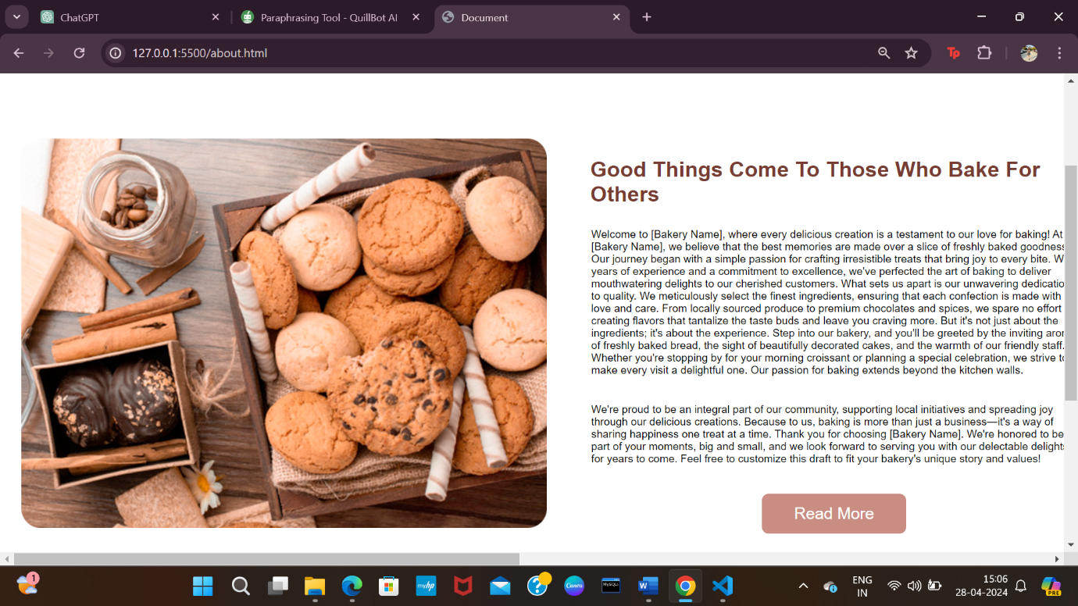

Product dropdown list

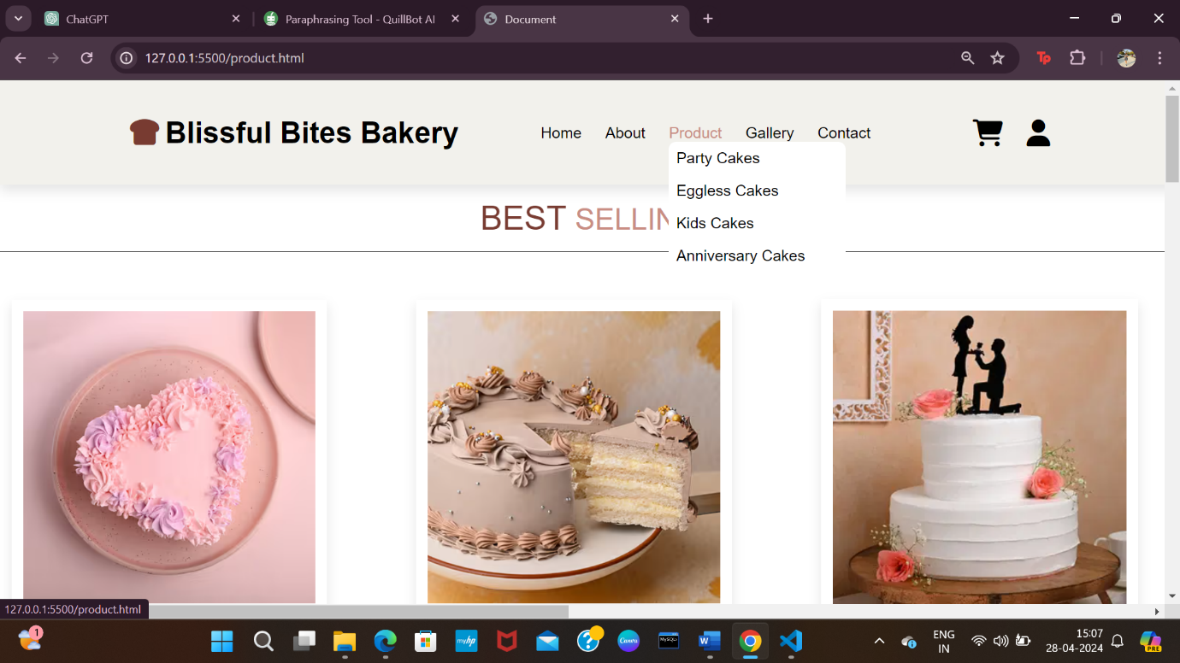

Gallery view

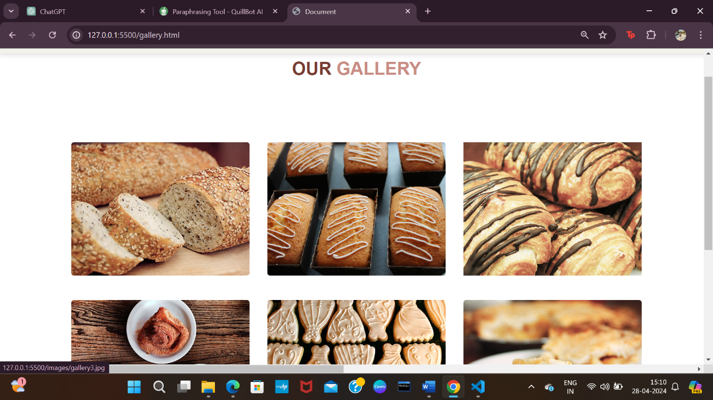

Contact page

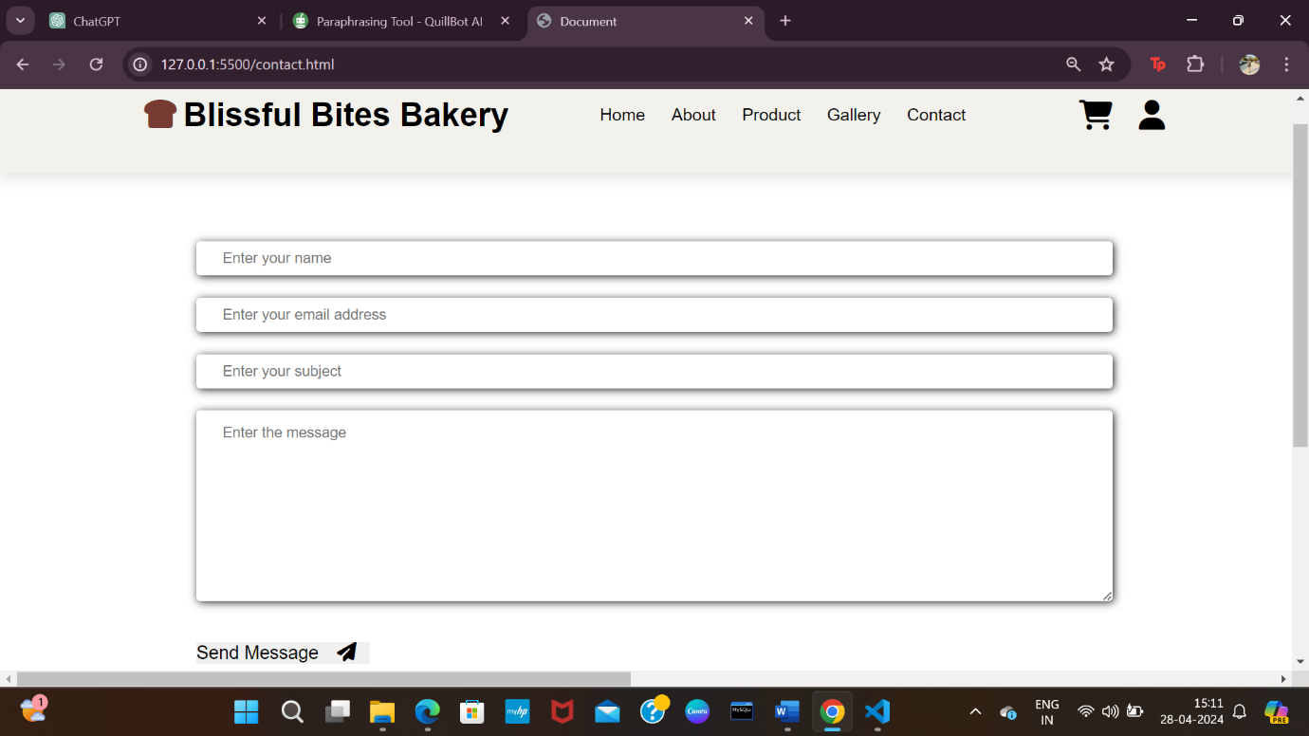

Shopping cart

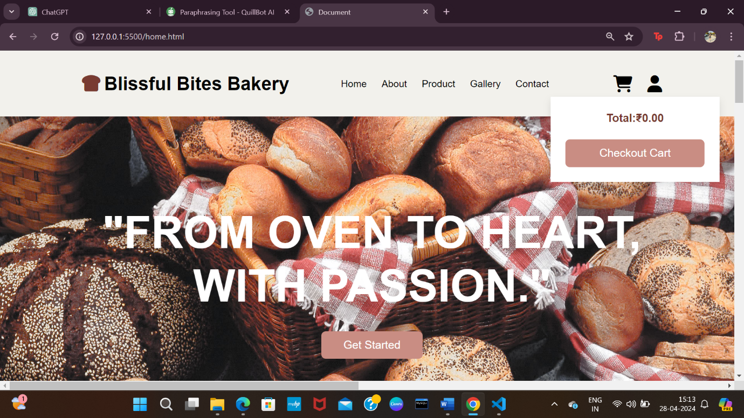

FUNCTIONAL REQUIREMENTS:

Functional requirements describe the specific features and functionalities of the website. These include:

* Login from
* Contact details
* Product
* Gallery
* Shopping Cart

NON-FUNCTIONAL REQUIREMENTS:

Non-functional requirements define the qualities or attributes of the websites. These include:

* Performance
* Scalability
* Reliability
* Usability

